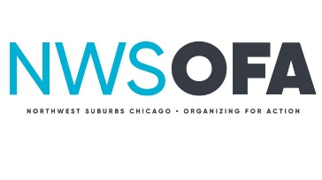Climate Change Team
Invites You to a FREE showing of “The Age of Consequences”
Arlington Hts. Memorial Library
Hendrickson Rm. South, 2nd Floor
500 N. Dunton, Arlington Hts. IL 60004
Tuesday May 29th
Doors Open at 6:30pm Meeting Starts at 7:00pm
RSVP: https://actionnetwork.org/events/nwsofa-climate-change-showing-of-the-age-of-consequences?source=email&
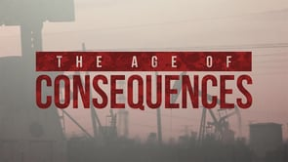
Please join us for "The Age of Consequences," which addresses the climate change and conflict nexus through the lens of national security and global instability. This documentary was directed by Jared P. Scott.
Dan Huntsha, North & West Suburbs Outreach Director of Faith in Place, will be our movie discussion facilitator.
We will also be sharing progress on our Mayors for 100% renewables project.
The big hit from the last meeting was the 1-Minute Activist exercise. Bring your ideas of ways we all can act to build healthy homes and communities.
Bring your friends and family
for an inspiring evening!

