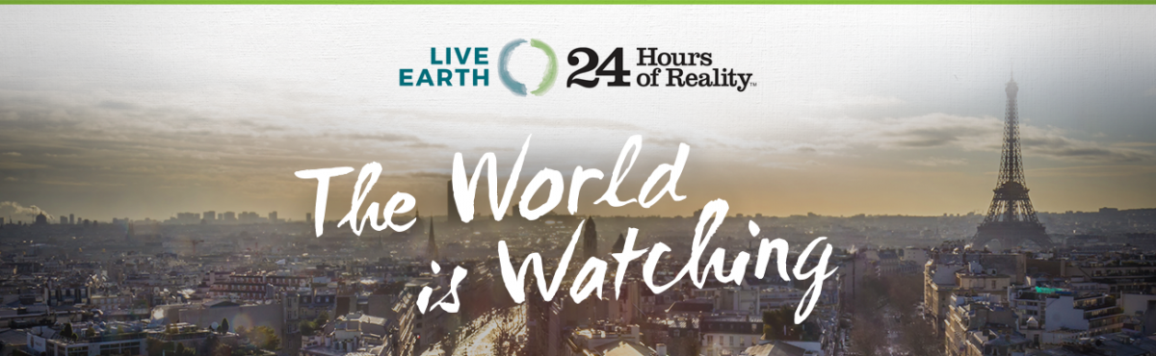

RSVP:
https://my.barackobama.com/page/event/detail/climatechangeactionevent/gsf7jg
Would you like to come to Arlington Heights Library to watch 24 Hours of Reality and Live Earth with us? We'll be watching the broadcast, speaking about action in Paris, and talking about the exciting developments in clean energy and other areas that are bringing the world to a turning point on climate change.

What makes this such a special even is that right now we will be having a special viewing of the documentary as world leaders are about to head to Paris to create a global climate agreement. So 24 Hours of Reality is bringing millions of people together all around the world to send a clear message to our leaders and make sure they take action.

EVENT DETAILS:
When: Friday November 13, 4:30 PM - 8:00 PM
Where: The Arlington Heights Library, 500 N Dunton Ave, Arlington Hts, IL 60004
Hope to see you there!

